Binary -> Octal

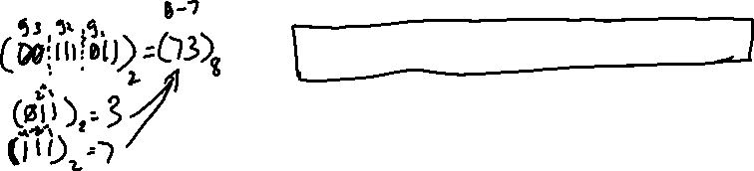

Octal -> Binary

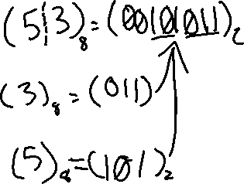

Binary -> Hexadecimal



Hexadecimal -> Binary

